Chapter 5

Exercise Solutions

Ex 5.1
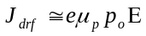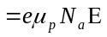
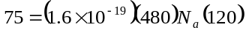
which yields 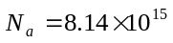cm
_______________________________________

Ex 5.2 Using Figure 5.2;
- 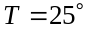C,
(i)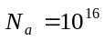cm, 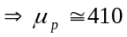cm/V-s
(ii)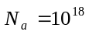cm, 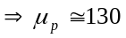cm/V-s
- 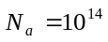cm,
(i)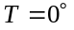C, 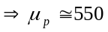cm/V-s
(ii)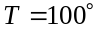C, 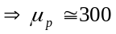cm/V-s
_______________________________________

Ex 5.3
(a) For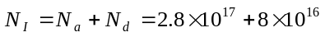
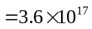cm,
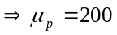cm/V-s
(b)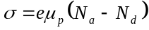
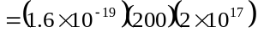
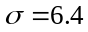(-cm)
- 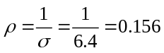-cm
_______________________________________

Ex 5.4
- 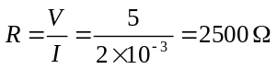
- 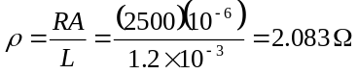-cm
- 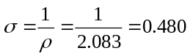(-cm)
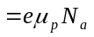
Then 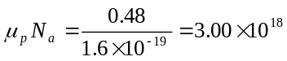
Using Figure 5.3 and trial and error,
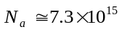cm
- 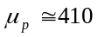cm/V-s
_______________________________________

Ex 5.5
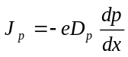
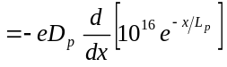
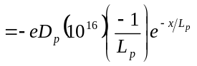
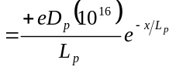
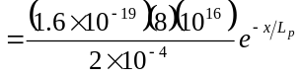
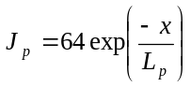
- For 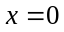,
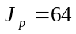A/cm
- For 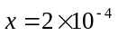cm,
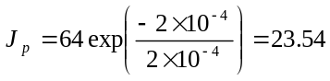A/cm
- For 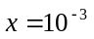cm,
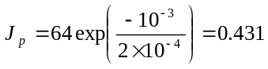A/cm
_______________________________________

Ex 5.6
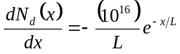
So
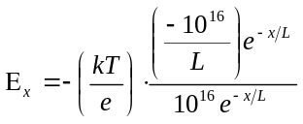
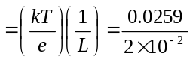
or 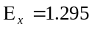V/cm
_______________________________________

Ex 5.7
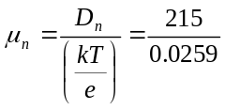
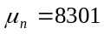cm/V-s
_______________________________________

Ex 5.8
From Equation (5.59),
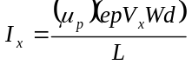
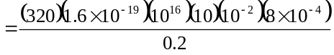
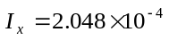A
or 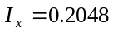mA
From Equation (5.53),
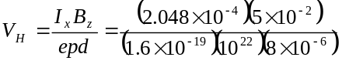
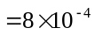V
or 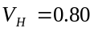mV
_______________________________________

Test Your Understanding Solutions

TYU 5.1
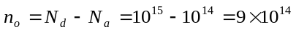cm
Also
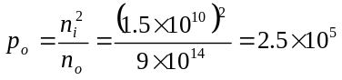cm
Now
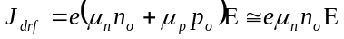
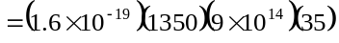
or
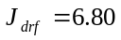A/cm
_______________________________________

TYU 5.2
- For 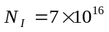cm,
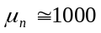cm/V-s; 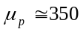cm/V-s

- 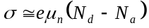
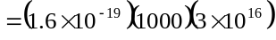
or
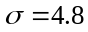(-cm)
We find
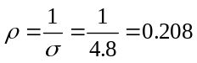(-cm)
_______________________________________

TYU 5.3
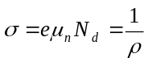
So
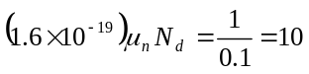
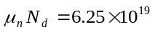
Using Figure 5.3 and trial and error,
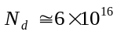cm and
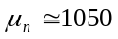cm/V-s
_______________________________________

TYU 5.4
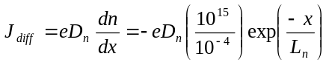
We have 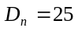cm/s
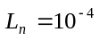cm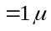m
Then
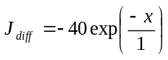A/cm
- , 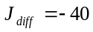A/cm
- 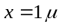m, 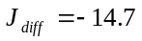A/cm
- , 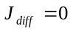
_______________________________________

TYU 5.5
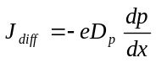
So
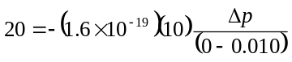
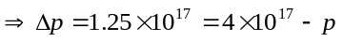
And
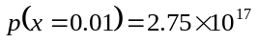cm
_______________________________________

